Town Hall,
Parliament Square,
Ramsey,
Isle of Man.

www.ramsey.gov.im

16th May, 2024.

Mr. Chairman and Members,

A Special Public Meeting of the Ramsey Town Commissioners will be held at 7.00 p.m. on Tuesday evening next, 21st May, 2024, in the Boardroom of the Town Hall, Ramsey.

BUSINESS:

- Apologies for Absence:
Mr. S. Kelly has been granted leave of absence

2. Area Plan for the North and West

3. Any other business
(by permission of the Chairman)

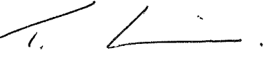

T. R. K. Cowin,
Town Clerk & Chief Executive.

